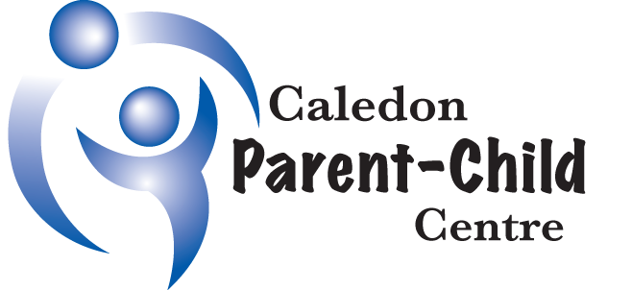  Strategic Plan  2018-2021  This document connects the Caledon Parent-Child Centre’s (CPCC’s) 3 strategic directions and sets the stage for our next 3 years.  Building on our knowledge of healthy development in early childhood and experience that families stay connected to us beyond the preschool years, this plan will drive us to be an organization that is leading edge in meeting the needs of ALL Caledon families.  We will bring families back into focus in our community and ensure that all families find a home with CPCC, including those with complex needs or barriers. CPCC’s long term goal is to be the go-to hub in the Caledon community that provides a holistic, integrated range of services and supports to families with children 0-12 years. |  | Ignite and Unite Families  Leverage the power of families through community engagement and development  We will engage in innovative awareness campaigns that target communities of interest AND amplify the voices of families and empower Caledon families to be agents of positive change in their community.

Deepen Our Response to Emerging Populations in Caledon
ENHANCE ACCESS TO ALL PROGRAMS AND SERVICES AND REDUCE BARRIERS TO ECHO A SENSE OF BELoNGING TO ALL

We will strengthen outreach strategies to engage with emerging populations AND continue to drive to excellence in service responses for all.
Position Ourselves to Respond to Need
Be nimble in meeting the needs of caledon families now and in the future
We will launch our strategic directions through building our capacity to innovate AND through pursuing new resource opportunities.
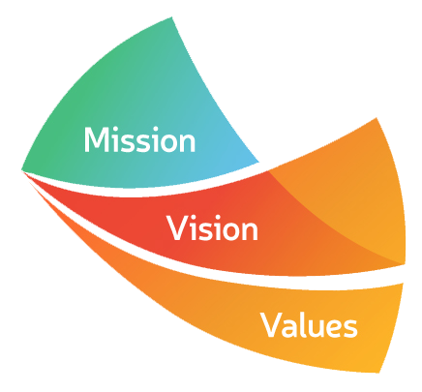
To provide support, resources and education that strengthen families and promote the optimal development of
children.

To be a leading member of an integrated system of community services that fosters the healthy development of
children and families, resulting in a strong and socially responsive community.

Collaboration • Inclusion • Accountability • Lifelong Learning • Nurturing Environment

